**Exercise_No:8**

**Date:23-11-2020**

**Aim:**

**To print the output for the given problem using python.**

**Program:**

**lst=[]**

**list1=int (input ("Enter number of elements"))**

**for x in range (0, list1):**

**val=int (input ())**

**lst.append((val, pow(val,3)))**

**lst1=sorted(lst)**

**print(lst)**

**print(lst1)**

**Link:**

[**http://103.53.53.18/mod/vpl/forms/submissionview.php?id=317&userid=1684#**](http://103.53.53.18/mod/vpl/forms/submissionview.php?id=317&userid=1684)

**output:**

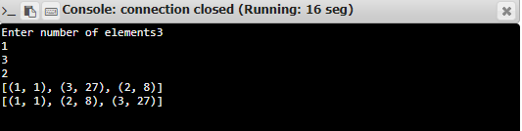

**Result:**

**Thus the python program is successfully executed.**